Experiment No: 4 Date:- 25-10-2020

AIM: To study C++ console I/O operations

THEORY:

In C++, the I/O stream is designed to work with different I/O devices. The I/O system provides an interface called the stream to the programmer, which is independent of the actual device being used. A stream is a sequence of bytes that serves as a source or destination for an I/O data.
Input stream is the source stream that provides data to the program and output stream is the destination stream that receives output from the program.
C++ I/O system contains a hierarchy of stream classes used for input and output operations, these classes are declared in the header file ‘iostream’.

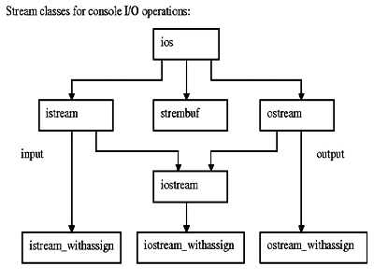

Stream manipulators
Manipulators are functions specifically designed to be used in conjunction with the insertion (<<) and extraction (>>) operators on stream objects, for example:
cout << showpoint;

They are still regular functions and can also be called as any other function using a stream object as argument, for example:
showpoint (cout);

Types of Manipulators
There are various types of manipulators:
- Manipulators without arguments: The most important manipulators defined by the IOStream library are provided below.
- endl: It is defined in ostream. It is used to enter a new line and after entering a new line it flushes (i.e. it forces all the output written on the screen or in the file) the output stream.
- ws: It is defined in istream and is used to ignore the whitespaces in the string sequence.
- ends: It is also defined in ostream and it inserts a null character into the output stream. It typically works with std::ostrstream, when the associated output buffer needs to be null-terminated to be processed as a C string.
- flush: It is also defined in ostream and it flushes the output stream, i.e. it forces all the output written on the screen or in the file. Without flush, the output would be the same, but may not appear in real-time.

- Manipulators with Arguments: Some of the manipulators are used with the argument like setw (20), setfill (‘*’), and many more. These all are defined in the header file. If we want to use these manipulators then we must include this header file in our program.
For Example, you can use following manipulators to set minimum width and fill the empty space with any character you want: std::cout << std::setw (6) << std::setfill (’*’);
- Some important manipulators in <iomanip> are:
  - setw (val): It is used to set the field width in output operations.
  - setfill (c): It is used to fill the character ‘c’ on output stream.
  - setprecision (val): It sets val as the new value for the precision of floating-point values.
  - setbase(val): It is used to set the numeric base value for numeric values.
  - setiosflags(flag): It is used to set the format flags specified by parameter mask.
  - resetiosflags(m): It is used to reset the format flags specified by parameter mask.

- Some important manipulators in <ios> are:
  - showpos: It forces to show a positive sign on positive numbers.
  - noshowpos: It forces not to write a positive sign on positive numbers.
  - showbase: It indicates the numeric base of numeric values.
  - uppercase: It forces uppercase letters for numeric values.
  - nouppercase: It forces lowercase letters for numeric values.
  - fixed: It uses decimal notation for floating-point values.
  - scientific: It uses scientific floating-point notation.
  - left: It adjusts output to the left.
  - right: It adjusts output to the right.

Source Codes

A] Write a C++ program to print the following output using ios class member functions
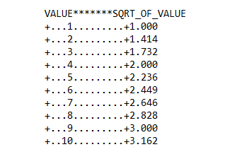
#include<iostream>
#include<math.h>
using namespace std;

int main()
{
cout<<"VALUE*******SQRT_OF_VALUE"<<endl;

int i=1;

cout.fill('.');
cout.precision(4);
cout.setf(ios::showpoint);
for(i=1;i<=10;i++)
{
cout.setf(ios::internal,ios::adjustfield);
cout.setf(ios::showpos);
cout.width(5);
cout<<i;
cout.width(15);
cout.setf(ios::right,ios::adjustfield);
cout<<sqrt(i)<<endl;
}

return 0;
}

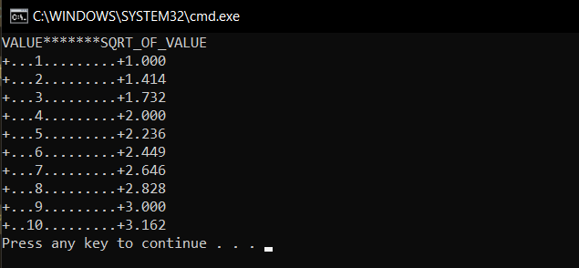

B] Write a C++ program which reads a text from keyboard and display the following information on screen in 3 column formats
- Number of lines
- Number of words
- Number of characters
Strings should be left justified and numbers to be right justified. Use suitable field width
#include<iostream>
#include<iomanip>
using namespace std;

int main()
{
char a[200];
int l=0,c=0,w=0;
long long unsigned int i;
cout<<"Enter your text. Press '#' followed by ENTER key to stop"<<endl; cin.getline(a,200,'#');
for( i=0;i<=strlen(a);i++)
{
if(a[i]=='\n')
l++;
if(a[i]==' ' || a[i]=='\0' || a[i]=='\n')
w++;
if(a[i]!=' ' && a[i]!='\n' && a[i]!='\t' && a[i]!='\0')
c++;
}
cout<<endl<<endl;
cout.setf(ios::left,ios::adjustfield);
cout<<setw(20)<<"Number of Lines"<<setw(20)<<"Number of Words"<<"Number of Characters"<<endl;
cout<<setiosflags(ios::right)<<setw(15)<<l<<setw(20)<<w<<setw(25)<<c<<endl<<end;
return 0;
}

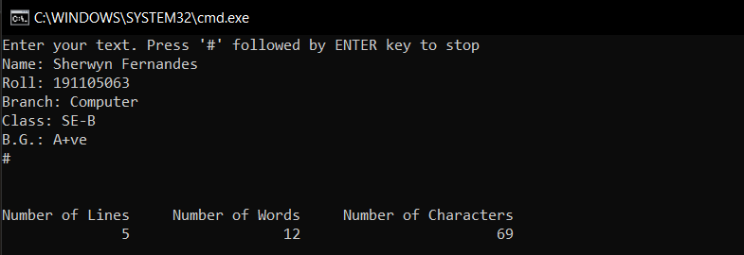

C. Write a C++ program to format the following o/p using manipulators(fig-expt4C)
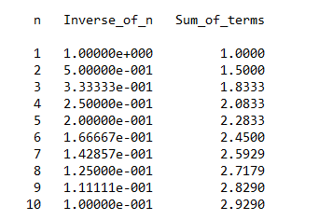

#include<iostream>
#include<iomanip>
using namespace std;

int main()
{
float z=0;
cout<<setw(5)<<"n"<<setw(15)<<"Inverse_of_n"<<setw(15)<<"Sum_of_terms"<<endl<<endl;
for( int i=1;i<=10;i++)
{
cout<<setw(5)<<i<<setw(14)<<setiosflags(ios::scientific)<<setprecision(5)<<1.0/(float)i<<setw(16)<<resetiosflags(ios::scientific)<<setiosflags(ios::showpoint)<<z+1/(float)i<<endl;
z=z+1/(float)i;
}
cout<<endl;
return 0;
}

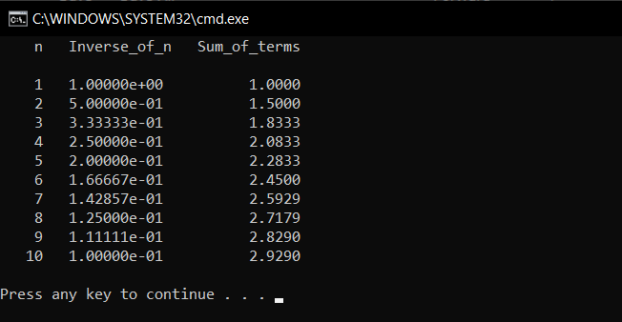

Conclusion: All programs were successfully run and executed to emphasize the working of iostream class manipulators and function manipulators.

- We can jointly use ios functions and manipulators in a program, when needed.
- The ios functions are mandatory to be used when the previous format state is to be saved.
- Some manipulator functions are more convenient to use compared to their counterparts in class ios since cascading is not possible in the latter.

